* What did you find? Which borough is the most expensive? Any other interesting trends?

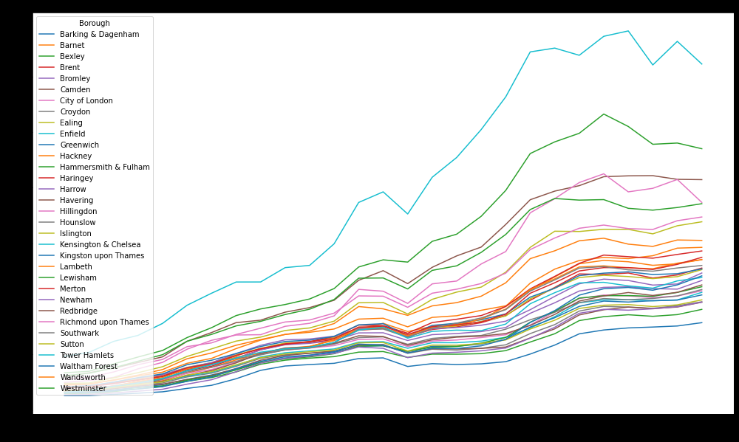

Kensington and Chelsea has always been significantly more expensive than any other borough.

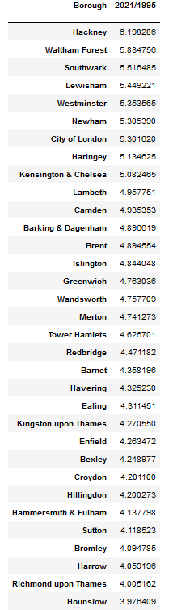

* How did you arrive at your conclusion?
* Highest percent increase: Took the avg price for each year for each borough and took the ratio 2021 to 1995 for each borough.
* Most expensive overall: Sorted that data by avg price for each borough. Graphed the results as well for a clearer answer.
* What were the main challenges you encountered? How did you overcome them? What could you not overcome?
* Biggest challenge was trying to retrieve avg prices for a [borough, year].
* I had to look this part up: dff = df.groupby(by=['Borough', 'year']).mean()
* For some reason trying to subset these rows just wasn’t working. This took me at least an hour of google searching after finally coming up with:

dff.loc[(index1, index2), :]

And then I intuitively added the column name to grab the value:

dff.loc[(index1, index2), :]['avg price']

- There wasn’t anything I didn’t overcome. I almost didn’t overcome my stress, but breathing got me through

* Is there anything you’d like to investigate deeper?
  + I want to be able to make visualization more appealing. I was looking into annotating graphs but it seemed more complicated than anything I’ve done so far.